Find the molecule in which the central atom is having one lone pair of electrons
A. NH₃
B. PCl₅
C. H₂O
D. CH₄
ANSWER: A
The shape of a molecule with three bond pairs and one lone pairs is..
A. hexahedral
B. octahedral
C. tetrahedral
D. trigonal bipyramidal
ANSWER: C
In $BrF_{3}$, lone pairs are present at the equatorial positions. This is to minimize
A. Bond pair – Bond pair repulsion only
B. Lone pair – Lone pair repulsion only
C. Lone pair – Bond pair repulsion only
D. both B. and (c)
ANSWER: B

Number of bond pair and lone pair electrons present on N atom in NO₃– are
A. 3, 1
B. 4, 0
C. 2, 2
D. 1, 3
ANSWER: B
The shape of a molecule with six bond pairs and no lone pairs is..
A. hexahedral
B. octahedral
C. tetrahedral
D. trigonal bipyramidal
ANSWER: B
Which of the following species has a shape based on two lone pairs and two bond pairs?
A. $NH_{3}$
B. $NH_{2}^{-}$
C. $NH_{4}^{+}$
D. $PH_{3}$
ANSWER: B
The molecule whose shape is based on lone pairs is...
A. $CH_{4}$
B. $CO_{2}$
C. $H_{2}O$
D. $SF_{6}$
ANSWER: C
The ion whose shape is not based on lone pairs is...
A. $NH_{4}^{+}$
B. $NH_{2}^{-}$
C. $H_{3}O^{+}$
D. $PCl_{4}^{-}$
ANSWER: A
The shape of a molecule with five bond pairs and no lone pairs is..
A. hexahedral
B. octahedral
C. tetrahedral
D. trigonal bipyramidal
ANSWER: D
Which of the following statements about ammonia molecules is not true?
A. they possess a lone pair
B. the H-N-H bond is 107°
C. they are pyramidal in shape
D. they are tetrahedral in shape
ANSWER: C
Which of the following statements about SO2 molecules is true?
A. the O=S=O bond angle is 180°
B. their shape is based on having two lone pairs and two double bond pairs
C. their shape is based on having one lone pair and two bond pairs
D. they are trigonal planar
ANSWER: D
The shape of a molecule with three bond pairs and no lone pair is..
A. trigonal planar
B. octahedral
C. tetrahedral
D. trigonal bipyramidal
ANSWER: A
The diagram shows:
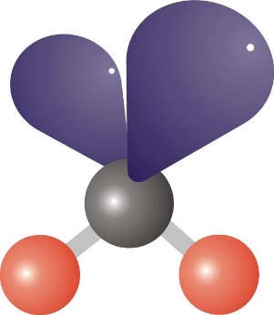
A. trigonal planar
B. tetrahedral
C. bent
linear
ANSWER: C

Which shapes are altered by unshared pairs of electrons alter?
A. Bent and Pyramidal
B. Trigonal Planar and Bent
C. Tetrahedral and Bipyramidal
D. Pyramidal and Linear
ANSWER: A

The structure is:
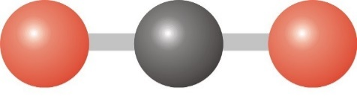
A. bent
B. trigonal pyramidal
C. tetrahedral
D. linear
ANSWER: D

The structure is:
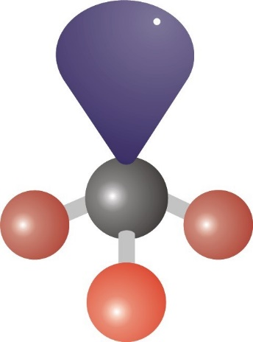

A. trigonal planar
B. trigonal pyramidal
C. bent
D. linear
ANSWER: B

